BERKSHIRE HILLS REGIONAL SCHOOL DISTRICT
serving the towns of
Great Barrington, Stockbridge, and West Stockbridge, Massachusetts

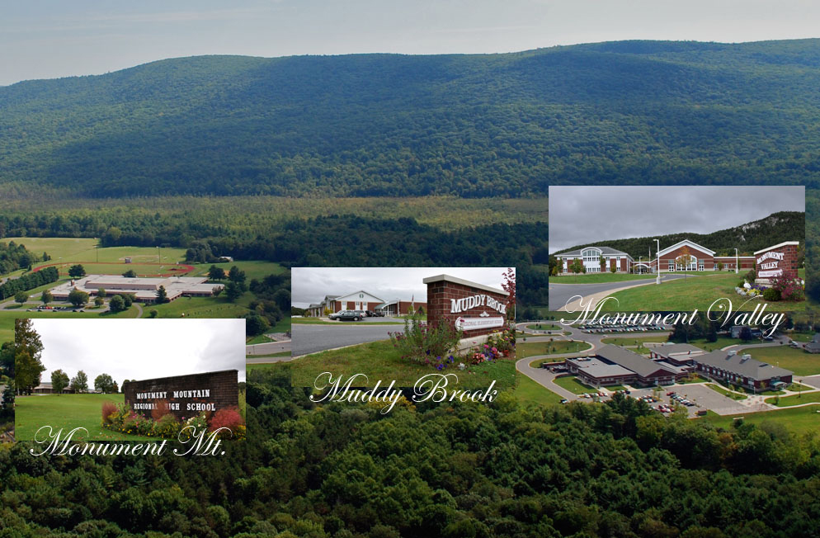
www.bhrsd.org
THE BERKSHIRE HILLS COMMUNITY
The Berkshire Hills Regional School District is comprised of three separate communities working together to provide all students the highest quality education and challenge them to explore and maximize their potential. The towns of Great Barrington, Stockbridge and West Stockbridge are located
in the Southwest corner of Massachusetts in the heart of the Berkshires.

Known for breath-taking natural beauty in all four seasons,
the Berkshires region is also an internationally renowned cultural and recreational mecca. Some of the better-known cultural attractions just moments away from the BHRSD campus are Tanglewood, summer home to the Boston Symphony Orchestra, Jacob’s Pillow Dance theatre, Berkshire Theater Festival, The Norman Rockwell Museum, Kripalu, Shakespeare & Company, Berkshire Botanical Gardens, the historic homes Chesterwood, Naumkeag and The Mount. Most of these institutions already work cooperatively with the district to offer extremely creative programs for our students at many levels from Elementary through the High School.

In addition to the cultural attractions, access to outdoor activities in all four seasons abound including skiing, golf, hiking, rock climbing, swimming, canoeing, kayaking and cycling. The district is only 2 ½ hours by car or train from both Boston and New York City.

THE BERKSHIRE HILLS REGIONAL SCHOOL DISTRICT
The Berkshire Hills Regional School District strives to provide innovative, exemplary programs at all levels, from pre-K to 12, for just over 1500 students. All three school buildings, Muddy Brook Elementary, Monument Valley Middle School and Monument Mountain Regional High School are situated on a stunningly beautiful 71 acre campus with spectacular views from every window. The district offices are housed in a newly renovated, state-of-the-art space in the heart of the charming village of Stockbridge, often memorialized in Norman Rockwell paintings as “America’s Hometown.”

The campus setting affords the district cross pollination of ideas among teaching professionals, as well as unique opportunities for inter-grade interaction and learning such as high school students giving history presentations for younger children studying the same period, middle school students walking up to see the play, a jazz performance at the high school or students of all levels collaborating on work at “Project Sprout,” the community garden whose harvest is being used in the cafeterias and donated to local food pantries.

BHRSD Mission Statement
In cooperation with the community, the Berkshire Hills
Regional School District will provide all students the highest
quality education and challenge them to explore and
maximize their potential, ensuring the acquisition of
knowledge and skills necessary to lead fulfilling lives.

Muddy Brook Elementary and Monument Valley Middle schools are both state-of-the-art facilities designed to be beautiful, functional and bristling with the latest technology. The district and the member towns are all extremely and justifiably proud of them and they are the envy of surrounding districts as well. BHRSD attracts four times more school choice students than it sends. Additionally, Monument Valley is an award-winning “Green School” boasting both solar and geothermal capabilities. While Monument Mountain High School was built in 1969, its maintenance and upkeep has been meticulous. It too has received national recognition as a school of academic excellence.

Finally, while the buildings are first rate and the campus setting is spectacular, the pride of the BHRSD is its highly experienced and dedicated staff. From administrators and teachers to custodians and food service workers, the pride and dedication are palpable. Parental support and community involvement are historically strong throughout the district. Through its outstanding staff and its focus on quality programs and student achievement, the district is a strong contributor to the superior quality of life in the region.

BHRSD VITAL STATISTICS
Student Enrollment: 1310
School Committee: 10 members from 3 towns
Professional Staff: 145
Non-Certified Staff: 95
Administrators: Superintendent, Business Administrator, Director of Student Services, Director of Learning & Teaching, Director of Operations

